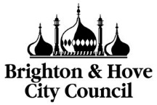
Admission arrangements 2026/27
Summary report
The purpose of this short paper is to provide a high level summary of what is covered in the officer report and appendices going to Full Council on 27 February 2025.
Read the School Admission Arrangements 2026-27 report to the 27 February 2024 Special Council meeting (agenda item 6) Brighton & Hove City Council - Agenda for Council on Thursday, 27th February, 2025, 3.00pm
Recommendations to Full Council
The recommendations listed within the report are as follows. That Full Council agrees to:
- make no changes to the council’s admission arrangements other than the proposed changes listed below and the detail provided within Appendix 5 which lists the proposed admission arrangements in full
- increase the Published Admission Number (PAN) of Rudyard Kipling Primary School from 30 to 45 for entry into reception year from September 2026
- amend the catchment area boundary between Longhill High School and Dorothy Stringer and Varndean schools
- reduce the Published Admission Number (PAN) at Blatchington Mill School from 330 to 300 for entry into year 7 from September 2026.
- reduce the Published Admission Number (PAN) at Dorothy Stringer School from 330 to 300 for entry into year 7 from September 2026.
- reduce the Published Admission Number (PAN) at Longhill High School from 270 to 210 for entry into year 7 from September 2026.
- make a change to the admissions priorities for community secondary schools, to provide that at any school the percentage of places for pupils eligible for Free School Meals within the oversubscription priorities 1-5 should be set at 30% of the Published Admission Number (PAN).
- the introduction of a new Criteria 6 within the oversubscription criteria for entry into community secondary schools in the city, to be referred to as Open Admissions. This is to be set at 5% of the total PAN of those schools and is only available to pupils living within a single school catchment area in the city.
- increase the number of preferences that families can express from three to four for admission from September 2026 onwards.
- make no change to the ‘relevant area’ for school admissions purposes.
- the proposed primary and secondary school coordinated schemes.
- note the intention to review the Home to School Transport Policy informed by the admissions scheme adopted by council, review capital expenditure on school buildings and the educational disadvantage strategy, Better Outcomes, Better Lives.
The admissions criteria for our community secondary schools for starting in year 7 in September 2026 would therefore read as:
- Looked after children and all previously looked after children, including those children who appear (to the council) to have been in state care outside of England and ceased to be in state care as a result of being adopted.
- Compelling medical or other exceptional reasons for attending the school.
- A sibling link applied for those living within the designated catchment area only.
- Children living within the designated catchment area and eligible for Free School Meals up to the city average.
- Other children eligible for Free School Meals up to the city average.
- Children living outside the school’s catchment area but within the catchment area for BACA, PACA, Patcham or Longhill up to 5%.
- Pupils living in the designated catchment area for the school(s).
- Other children.
Within all these priorities, the tie break is random allocation
For criteria 2, compelling medical or other reasons, a short appendix is provided which clarifies how those applications can be made, what is needed to be provided and how decisions will be made by a panel of relevant professionals. This is a clarification on how it has worked in previous years.
For free schools meals, where we apply the city average as a ‘cap’ in priorities 4 and 5, we will start the count towards that quota from criteria 1. Therefore, where children admitted to the school under priorities 1, 2 and 3 are eligible for free school meals, their allocations will start the count towards that 30%. The intention is to ensure more of an ‘easing’ of the distribution of free school meals children across city schools. This is change from how the policy was implemented in 2025 and we feel this change is needed due to the other changes we are now making to the admission arrangements, for example with the introduction of open admissions.
For the catchment area, we are proposing the changes as shown below – with the BN2 5 north area above Manor Way and Manor Hill to be brought within the Varndean/Dorothy Stringer catchment area (shown in yellow below), moving out of the Longhill High School catchment area.
To ensure the geographic spread of secondary schools and continued alignment of pupil numbers and places, it is proposed that the Kemptown area BN2 1 and BN2 5 (south) would move into the Longhill High School catchment area (shown in salmon pink below). Where we have changed the catchment area, we would honour the sibling link (which normally only applies if you live in the catchment area) as long as the older child is still at the school when the year 7 sibling starts.
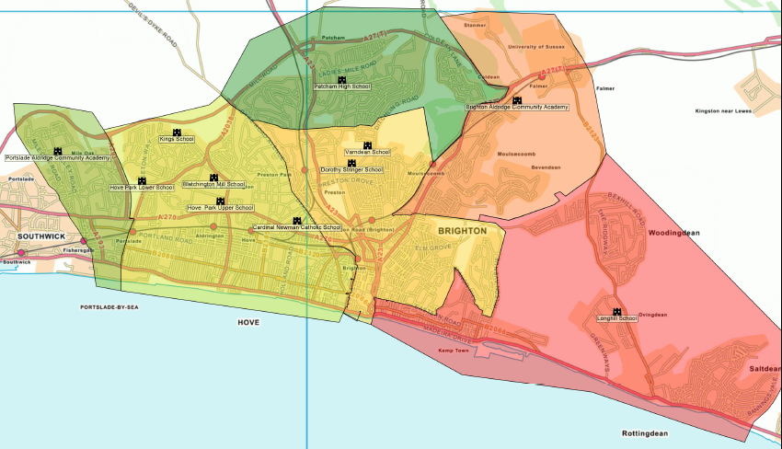
Summary of the public consultation responses
The public consultation ran from 6 December 2024 to 31 January 2025.
Responses were received via the YourVoice survey, emails direct to the school oganisation inbox, member enquiries, general enquiries, attendance at public meetings and 2 written responses were received.
Many respondents expressed concerns about the potential negative impacts of the proposals.
There were significant concerns about the negative impact of long journeys for children, especially those with special educational needs (SEND) or mental health issues (either pre existing or bought on as an impact of these changes).
Doubts were raised about whether the proposals would improve educational outcomes, with some suggesting that resources should be focused on improving schools rather than redistributing pupils.
Many respondents in the DS/V catchment expressed the view that they had worked hard to be able to afford to live in the catchment and felt the open admissions proposal undermined this hard work.
Alternatively, many respondents supported the proposals, viewing them as a necessary step to address long-standing inequalities in the city's education system.
They believed that both the FSM criteria and catchment change could provide better opportunities for disadvantaged children and that the ‘open admissions’ criteria could create a fairer system for school allocations.
Parents in single catchment areas expressed the view that currently families in central dual catchment areas were offered two popular/high preference city catchment schools, while families in single catchment areas were typically limited to one low preference city catchment school that was undersubscribed.
It was suggested that this situation means that many families are currently priced out of accessing high preference schools. There was also support for the idea of creating a more inclusive environment for underrepresented communities.
Overall, while there was broad appreciation for the policy's intentions, there were substantial concerns raised about its implementation and potential unintended consequences.
Brighton & Hove City Council, February 2025

