Possible changes to library services in Brighton & Hove


The council is suggesting changes to the library services in Brighton & Hove


The council is suggesting the following changes
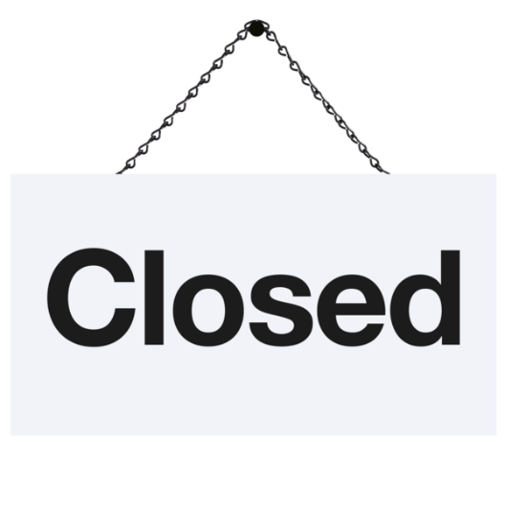
Closing three libraries:

Hollingbury Library

Rottingdean Library

Westdene Library

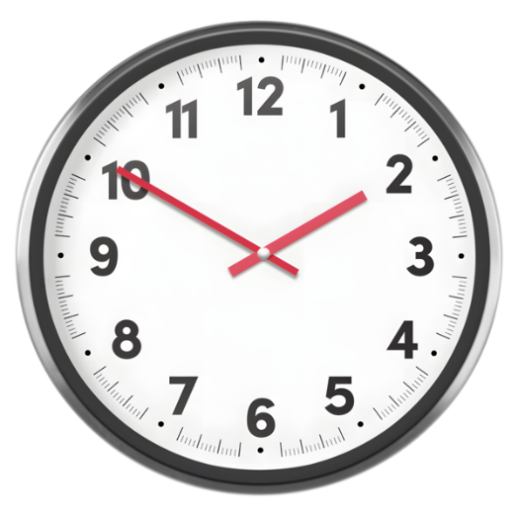

Reducing opening hours at:

Jubilee Library
2 hours less on Monday evenings
3 hours less on Sunday afternoons
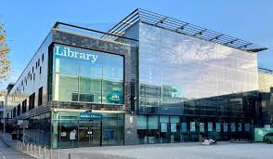

Hove Library
2 hours less on Wednesday evenings 3 hours less on Saturday afternoons
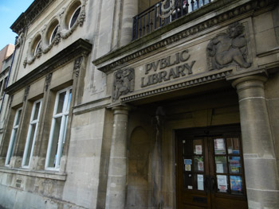

We want to hear from you


This consultation is open until 10 October 2025

This website has an online survey
Project: Sustainability plan for libraries | Brighton & Hove City Council

You can pick up a paper copy in any library


You can email us here:
Libraries.consultation@brighton-hove.gov.uk

You can attend any of these events
Project: Sustainability plan for libraries | Brighton & Hove City Council (go to the bottom of the page for events details)



Thank you


